**TABLE: CHARITY**

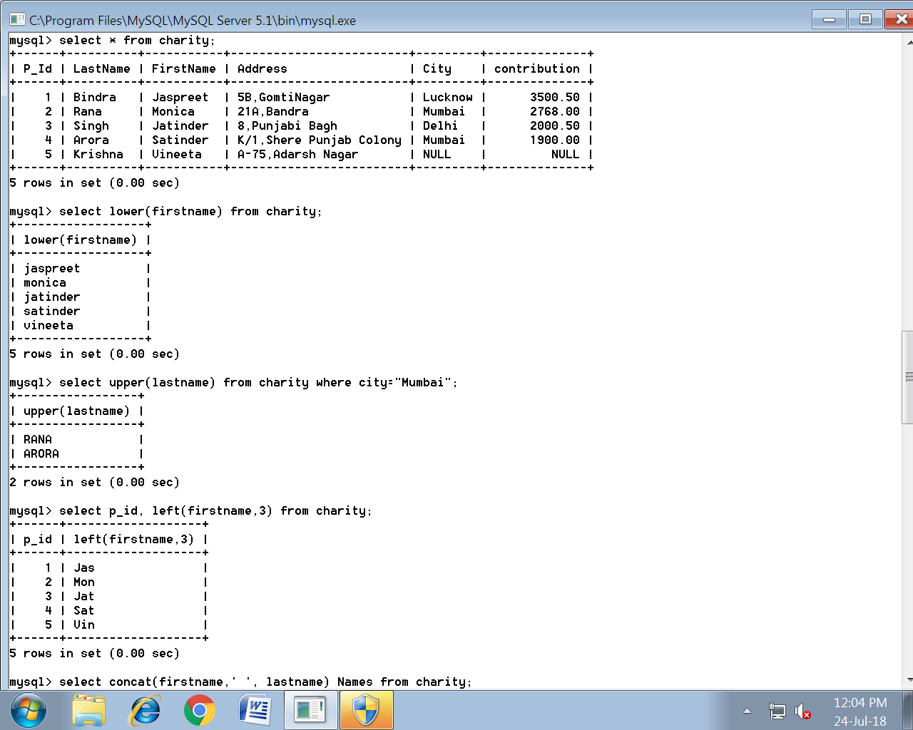

**Queries:**

1. Display all first names in lowercase.
2. Display all last names of people of Mumbai city in uppercase
3. Display Person Id along with Frist 3 characters of his/her name
4. Display first name concatenated with last name for all the employees
5. Display length of address along with person Id
6. Display last 2 characters of City and Person ID
7. Display Last names and First names of people who have “at” int the second or third position in their first names.
8. Display the position of ‘a’ in Last name in every row.
9. Display Last name and First name of people who have ‘a’ as the last character in their first names.
10. Display the first name and last name concatenated after removing the leading and trailing spaces.
11. Display Person ID, last names and contribution rounded to the nearest rupee of all the persons.
12. Display Person id, last name, and contribution with decimal digits truncated of all the persons.
13. Display Last name, contribution and a third column which has contribution by 10. Round it to two decimal digits.

**1**



**2**



**3**



**4**

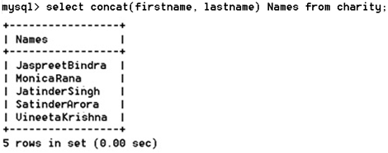

**5**

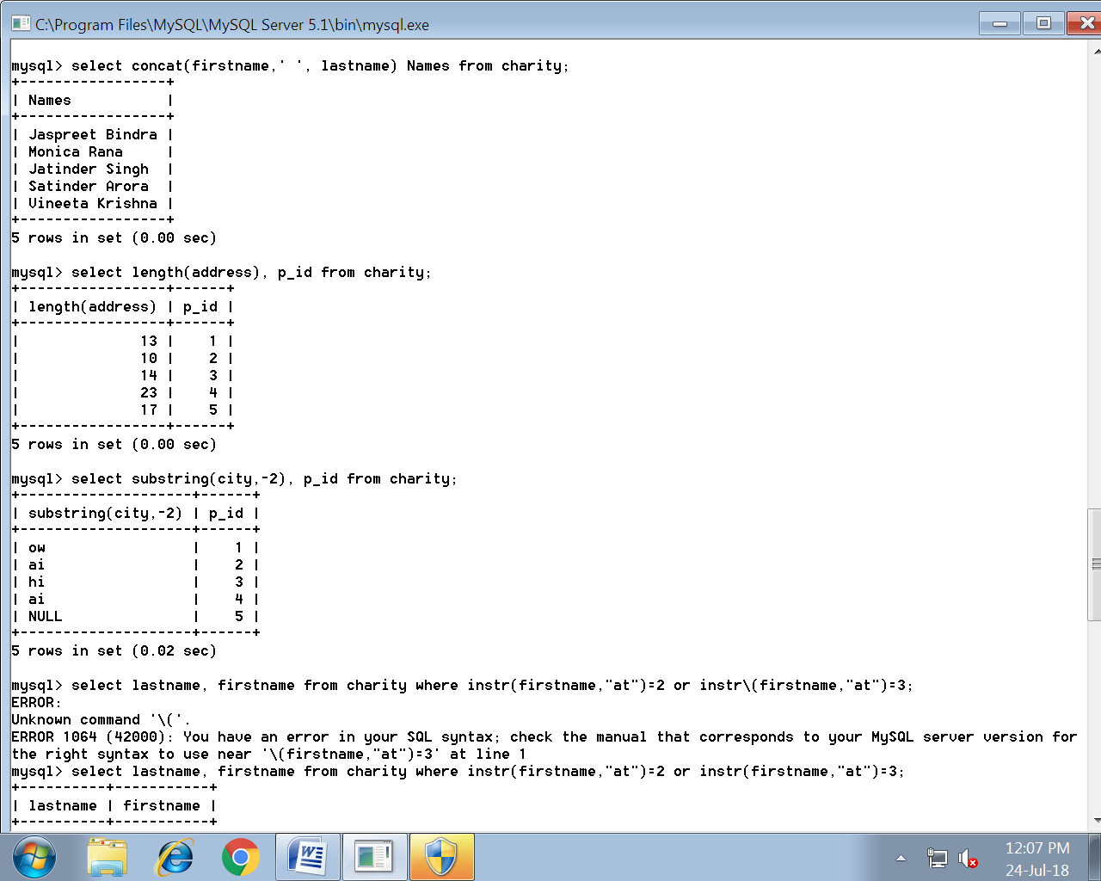

**6**



**7**

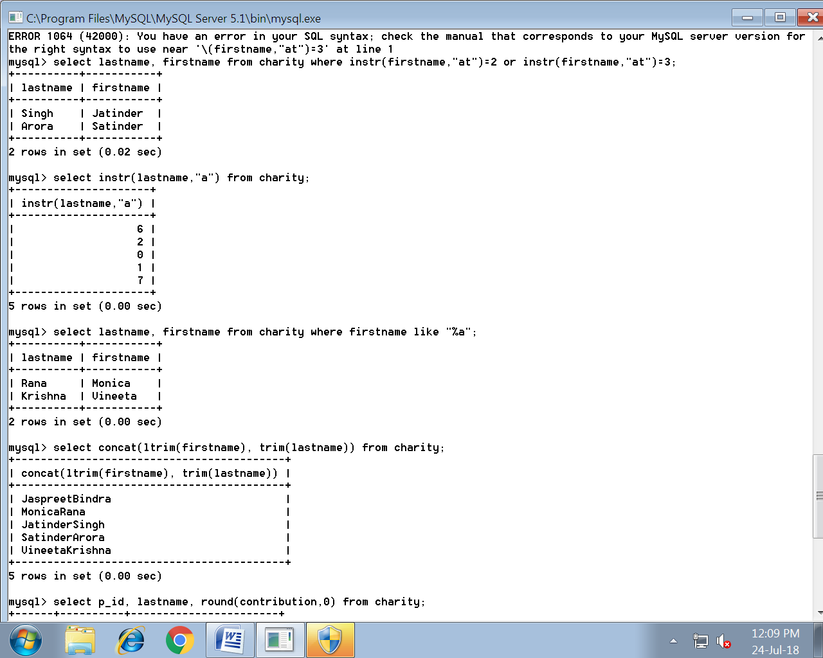

**8**



**9**



**10**

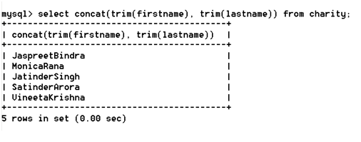

**11**

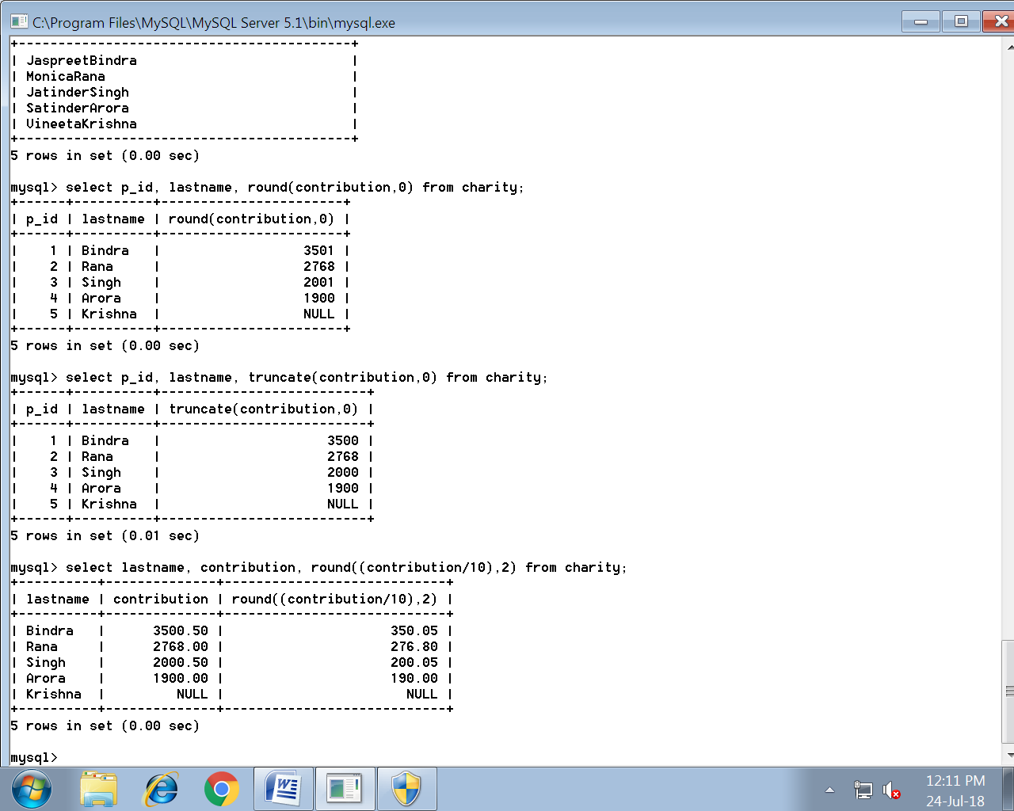

**12**



**13**

